**NYSSMA Festival**

Westchester (Zone 11)

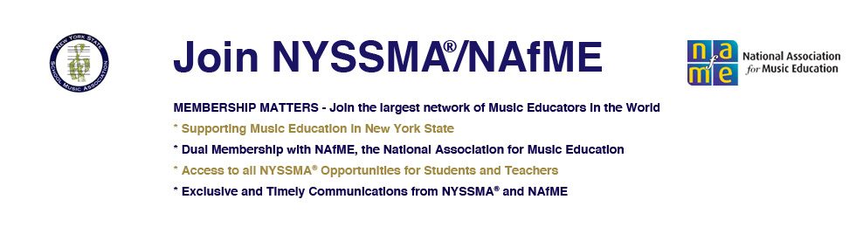

**String Regular Solos Information Packet**

FAQs

Requirements for each level (1-4):

Scales

Sight-Reading

Repertoire

Basic Scales for every instrument (Violin, Viola, Cello, Bass)

**Sight-reading binders are available at PKMS for students to practice at school. Extra copies of forms and music are also available at PKMS and on my teacher page.**

*Please contact me with questions at*[**cfinney@peekskillschools.org**](mailto:cfinney@peekskillschools.org)

Carolee Finney

Orchestra Director

Peekskill Middle School

**FAQs from the NYSSMA Website**

[**https://www.nyssma.org/parents-students/**](https://www.nyssma.org/parents-students/)

**Parents, Students and Private Teachers** – All questions concerning students, repertoire, registration or scheduling should go through the students’ school music teacher, guidance councilor or building administrator.

1. What is a NYSSMA festival?

NYSSMA sponsors approximately 145 solo & small ensemble and major ensemble festivals in New York State each spring. At solo and small ensemble festivals, students are given a performance evaluation that involves playing a graded solo from the NYSSMA Manual, playing scales and sight reading. At major ensemble festivals, school bands, choruses and orchestras are evaluated.

2. How do I register my child?

All NYSSMA registration is done through the student’s school music program. Information regarding scheduling times and appropriate materials should be received from the school music teacher or the head of the school’s music department. The school district or private school must be a school member of NYSSMA.

3. Can I register directly as an individual or through my child’s private music teacher or studio?

No. Registration is only done through the music program at the school which the student attends.

4. Is this a competition?

NYSSMA festivals (other than for All-State) are evaluations, not competitions. Students may compete with themselves from year to year, but NYSSMA does not view festivals as competitive.

5. What music can be played?

Students who desire a rating must choose a graded solo from the NYSSMA Manual. Student who desire comments only can perform any music and are not required to play scales or sight read.

6. Where can I see a manual?

Most schools and many teachers have a copy of the NYSSMA manual. It can also be found at many public libraries. The manual can be purchased at [www.nyssma.org/manual](http://www.nyssma.org/manual) The manual contains rules and regulations as well as the extensive solo lists. It should be noted, however, that the manual is designed for use by music teachers and is not intended as a student or parent publication.

7. Do I need a 2nd copy for the adjudicator?

A second copy of the solo is highly recommended, but not required. A piano accompaniment part may be used as the second copy, although it is important to be sure the solo part in the piano copy exactly matches the solo that the student will perform.

8. What about photo copies?

Any legal copy may be used, but if the legality is in doubt, it is wise to check on it before the day of the festival.

9. Do I need an accompanist?

Accompanists are not required except for All-State.

11. Who are the adjudicators?

NYSSMA adjudicators are professional teacher/musicians who have received instruction on the NYSSMA adjudication system.

12. What is Conference All-State?

The All-State bands, choruses, orchestras and jazz ensembles are honors groups comprised of the top students from school music departments across the state. The 8 groups are directed by renowned guest conductors and perform on one of three concerts in the Eastman (Rochester) Theater during the annual NYSSMA Winter Conference in late November or early December each year. Rehearsals take place in Rochester, NY from Thursday through the Sunday concert during the conference.

13. What are the eligibility requirements?

* To be eligible, a student must be a member of the corresponding ensemble in his or her high school if the school has such an ensemble. This would be the school band, chorus, orchestra, jazz ensemble or vocal jazz ensemble. Students must be members at the time of the audition and at the time of Conference All-State. Students are chosen to represent these ensembles from their schools, and as such, must be participating members of their school ensembles.

14. Where can I get more information?

The primary source for festival information is your school music teacher or the head of the music department in the school you attend.

15. Question: The solo my son/daughter is performing has many movements. How many do they need to prepare and perform?

Answer: “Except where otherwise indicated, in the Manual listing, soloists preparing a multi-movement work will prepare and perform two contrasting movements. Theme and variations are not considered multi-movement works.” [page R-15, 7th bullet under General Solo Information]

16. Question: How many scales do students need to know?

Answer: Scale requirement vary slightly depending on the instrument. The general requirements are: Three prepared major scales for Level I and II. Seven prepared major scales for Levels III and IV and fifteen prepared major scales for Levels V and VI. Students must play these scales from memory. In every case, only three scales are chosen for evaluation. The scales to be evaluated are selected by the adjudicator. (Refer to the first page of each solo section (right after the tab page) in the NYSSMA Manual).

**Scale Requirements**

Level 1-2: Prepare and perform:

* 3 major scales from memory
* One octave
* Ascending and descending quarter notes at moderate speed

Level 3-4: Prepare:

* 7 major scales from memory (2 = two octave)
* Ascending and descending quarter notes at moderate speed

Perform:

* 1 two-octave scale
* 2 one-octave scales
* All 3 chosen by adjudicator

**Sight-Reading Requirements**

Level 1: D major, moderate speed, 2/4 and 4/4, D/A strings, quarter/half/whole notes, metso forte

**add**

Level 2: G major, 3/4, G string, slurs, eighth/dotted notes

**add**

Level 3: C/F major, dotted eighth notes, sixteenth notes, staccato, piano/forte

**add**

Level 4: Bflat/A major, cut time, E string, dotted eighth notes, eighth rests, crescendo/decrescendo

**Repertoire Requirements**

You **must** have your own purchased copy of the music (**no photocopies!!!)**.

Photocopies for page turns are acceptable.

You may choose to receive a “comments only” evaluation. You must perform a piece, but you do not have to perform scales or sight-read.

Level 1: Easy keys, meters, ranges, rhythms

*Level 2: May include changes of tempo, key, meter, mood

*Level 3: Increasing demands of techniques, ranges, interpretation

*Level 4: Moderately difficult

Method books that contain acceptable solos

(must check against NYSSMA manual):

Applebaum: String Festival Solos

Etling: Solo Time for Strings

Suzuki Books 1-4