**Art Rubric**

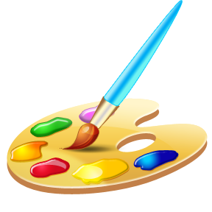**C:\Users\Liz\AppData\Local\Microsoft\Windows\Temporary Internet Files\Content.IE5\FG4M0XKE\MC900156487[1].wmf**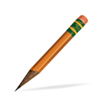

* **Craftsmanship**
* **Creativity/Style**
* **Drawing/Painting/**

**Sculpting**

* **Follows Directions**
* **Time Management**